Nama : Yulianus Sarang/165410023  
Praktikum : Teknologi Cloud Computing Lanjut   
Pertemuan : 4

**Step 1 - Running A Container**

#### Step 2 - Finding Running Containers

#### Step 3 - Accessing Redis

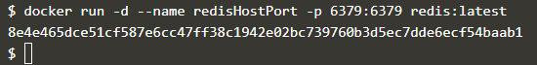

#### Step 4 - Accessing Redis

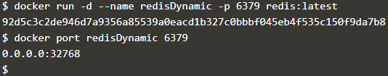

#### Step 5 - Persisting Data

#### Step 6 - Running A Container In The Foreground

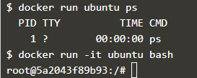  
**Membuat Image Docke**

